# Lesson 10 单词讲解

1.jazz n. 爵士音乐2.musical adj. 音乐的3.instrument n. 乐器 4.clavichord n. 古钢琴5.recently adv. 最近

1. damage v. 损坏（可修复）

destroy 猛烈的损坏

ruin

一点点的损坏

Spoil

精神得损坏

1. key n. 琴键key structure key point
2. string n. （乐器的）弦
3. shock v. 使不悦或生气,震惊

surprise

1. allow v. 允许，让
2. touch v. 触摸

# Lesson 10 课文&语法讲解

Key points:

被动语态

be + done

条件：及物动词或者不及物动词+介词

狗吃了那个蛋糕。

The dog ate the cake.

狗吃了那个蛋糕。主语 宾语

蛋糕被狗吃了。

被动语态

be + done

教室每天都打扫。

Classrooms (clean) every day.

被动语态

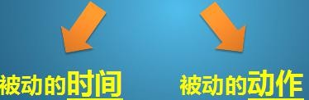be + done

被动语态

be + done

教室每天都打扫。

Classrooms are cleaned (clean) every day.

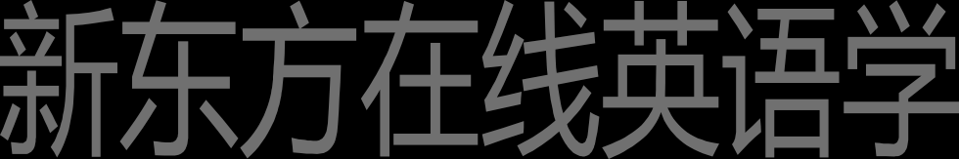被动语态

be + done

一座新的大楼去年建造的。

A new building was built (build) last year.

被动语态 be + done

他每天被打。 他昨天被打了。

他明天将要被打。他现在正在被打。



被动语态 be + done

他每天被打。 He is beaten every day.

他昨天被打了。 He was beaten yesterday.

他明天将要被打。 He will be beaten tomorrow.

他现在正在被打。 He is being beaten.

现在进行时的被动语态：am is are + being +done

被动语态 be + done

English is spoken (speak) all over the world. The stadium was built (build) in 1998.

被动语态 be + done

罗马不是一天建成的。

Rome was not built in a day.

人们现在正在被广告所影响。

People are being influenced by advertisements.

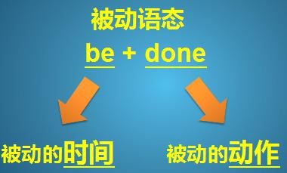

* 1. We have an … musical instrument. 2.It is called a clavichord.

1. It was made in Germany in 1681.
2. Our clavichord is kept in the living room.
3. It has belonged to our family for a long time.
4. The instrument was bought by my grandfather many years ago. 7.Recently it was damaged by a visitor.
5. She tried to play jazz on it!
6. She struck the keys … two of the strings were broken. strike struck struck

break broke broken 10.My father was shocked.

* 1. Now we are not allowed to touch it.
  2. It is being repaired by a friend of my father's.

It is being repaired by a friend of my father's. a friend of my father’s (friends)

名词所有格：

Lily’s book

the door of the room

# Lesson 10 知识拓展

本课重点:

被动语态

be + done

被动语态

The teacher helps me.

I am helped by the teacher.

The teacher helps Jane.

Jane is helped by the teacher.

The teacher helps us.

We are helped by the teacher.

被动语态

A college student bought my old car.

My old car was bought by a college student.

The secretary will fax the letters.

The letters will be faxed by the secretary.

被动语态

That company employs Alicia.

Alicia is employed by that company.

Bob is mailing the package.

The package is being mailed by Bob.

本课重点: 被动语态

be + done